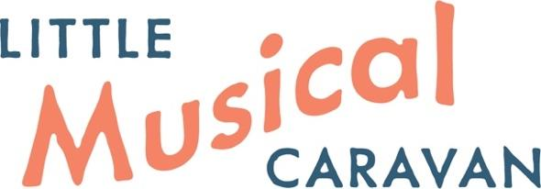
Newsletter December 2025

Welcome to our 2025 Newsletter! It’s been a busy year for the Little Musical Caravan, with more exciting things planned for next year…
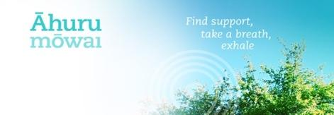
Partnership with Āhuru Mōwai Trust
Our music therapy ‘taster’ sessions in partnership with Āhuru Mōwai Trust continue to provide a blend of individually designed environments and personalised musical play for children and families with neurodiversity and/or additional needs. This year, Āhuru Mōwai Trust relocated their sensory sessions to Chipmunks in Tawa due to the closure of Awesome Bounce. We also welcomed new music therapists to run these sessions; Marianne Wren and then Deb Bellringer. Midyear, we ran another survey to gauge whānau responses to our service. This showed that these sessions helped families to access and learn more about music therapy. One respondent described it as “a child-led introduction to music” which we loved! Many people told us how much their child(ren) looked forward to their weekly session and the benefits they saw - including ones that lasted beyond the session itself. For example, one parent said:
[My child] enjoyed the therapy. She interacted with a lot of the instruments and also demonstrated a curiosity to try new things that she has taken outside of therapy. She also demonstrated shared attention by singing along and dancing to the songs. She waited and took turns playing drums, guitar and keyboard! … She absolutely gained new sounds and exploration of more sounds and textures… After the sessions she would be more “chatty” making more sounds and trying out new sounds and sound sequences”.
‘Taster’ sessions will continue at Chipmunks in 2026 and we look forward to another year supporting this awesome community of families. The reduced pricing we can offer for these sessions really makes them more affordable but it does mean we are building up a waiting list for next year so please be in touch with us as soon as possible if this is something you’d like to explore or recommend to a family you know. Chipmunks ‘taster’ sessions.
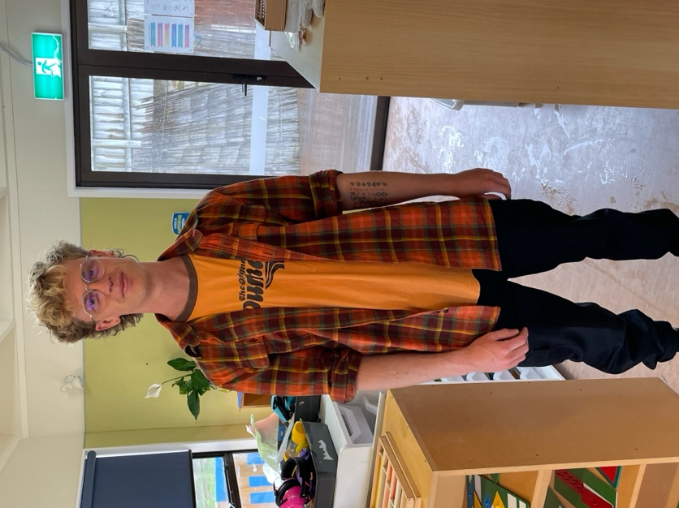
Student Music Therapist
This year we had the pleasure of hosting final-year Music Therapy student, Max McAlpine, for three terms as he worked towards completing his Master of Music Therapy with the New Zealand School of Music (NZSM), Victoria University, Wellington. Max brought a depth of musical skill and wealth of experience in working with children to his work. His creativity, guitar skills, ability to deeply consider his approach, and willingness to try new things were fantastic. The whole team enjoyed learning together and reflecting on the way that music therapy can make a difference for people. As a trained teacher who was now in a ‘student’ role again, Max’s placement also helped us all to consider the value of ako where anyone can be tuakana (more expert/ older) or teina (less experienced/ younger) in a learning relationship as we collaborate to find out what works best for each young person in their context.
Many thanks to our host schools, Adventure School, St Theresa’s School and Montessori Primary for supporting Max on his learning journey.
Adaptive Piano Lessons
At the Little Musical Caravan, we love innovating and finding ways to bring the best possible experiences to our community. This year we started offering adaptive piano lessons on Saturday mornings from our Hub in Mana. The purpose of these lessons is to offer an introduction to the piano for young people who may need a more flexible and accessible approach to learning. These were initially offered by the wonderful Katherine Spinks until she took up a fulltime position serving the community as a Pharmacy Assistant in Mana. Emily continued this work initially in term 3, and then we welcomed the fabulous Max McAlpine in Term 4 to this role after he finished his Music Therapy student placement with us.
Host Schools
We really value being able to bring our music therapy services to where our participants are already part of their communities. We couldn’t do this without the incredible support of families and learning centres so a big thank you to our 2025 Host schools: St Theresa’s School, Plimmerton; Adventure School, Whitby; Churton Park School; Redwood School, Tawa; Pauatahanui School; Plimmerton School; Porirua School, Elsdon; and Maraeroa Kindergarten, Cannons Creek. It has been a pleasure working with you to support your ākonga.
Welcoming Deb
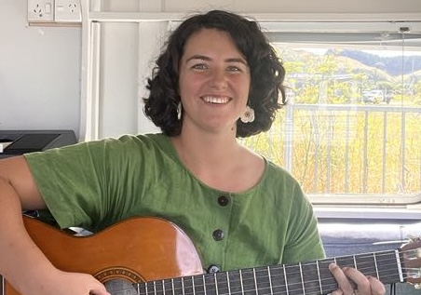
Registered Music Therapist Deborah Bellringer joined the Little Musical Caravan Team this year and we are so glad! Deb brings a beautiful gentle energy to her work with children and is superb at following children’s lead in their play. Deb has a degree in performance music where she majored in recorder - proving that an instrument which is often misunderstood can be developed to an extremely high level of competence. Did you know that recorders come in many different sizes?! Deb can play them all - as well as many other instruments. Her recent enthusiasm for accordion has been a great hit with many children.

Farewells
Deb joined the team to replace Marianne Wren who left Aotearoa to adventure around the world. We have missed her lively energy and aroha but know she’s having a wonderful time exploring!

We also farewelled Katherine Spinks in Term 3 of this year as she left the role of Adaptive Piano Tutor for a full-time role as a Pharmacy Assistant. We are really grateful to Katherine for her skills which helped to establish this important new service at the Hub.
TJ - Team Leader
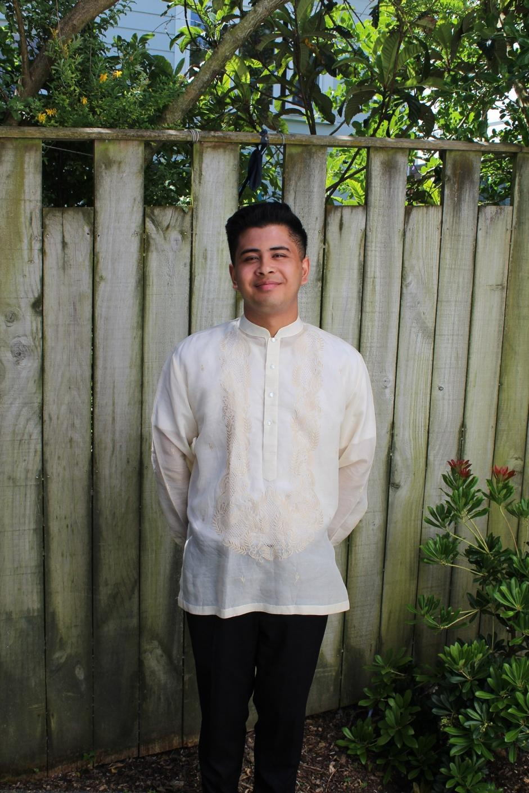
TJ took on the team leader role at the end of last year in preparation for supporting our music therapy student, Max, with his studies as a Clinical Liaison. This was a really enjoyable challenge for TJ and he loved the reflective conversations that came through this relationship. After two years of fulltime practice, TJ appreciated being encouraged to reflect on his own practice to ensure he was modelling music therapy well. It was also exciting for TJ to realise how much his own practice has developed since he first graduated. TJ’s gentle, approachable, collaborative, thoughtful and playful qualities are highly valued by LMC team members and families alike!
Play-based music therapy groups with Liz
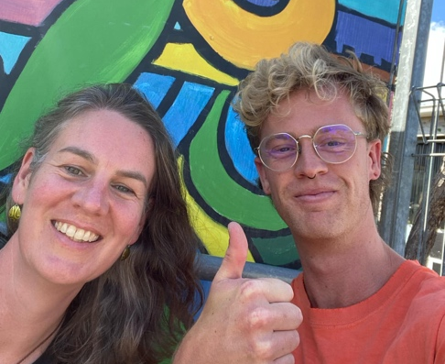
This year, Liz continued visiting Maraeroa Kindy in Cannons Creek to offer all-comer play-based music therapy sessions to their ākonga. Our child-led and strengths-based approach were a great match with the kindy’s values and we were all disappointed when the funding for these sessions ran out. If you know of any sources of funding for this really important work, please reach out to Maraeroa Kindy or the Little Musical Caravan! A spark of the work was captured in this learning story; I want to play guitar!
Liz also worked with Te Whare Tiaki in Porirua to trial a group for supporting women and preschool children experiencing family violence. We learned a lot from this process and although we haven’t continued this work at this time, it remains a passion for us to continue to explore how we can use our music therapy skills (and Liz’s additional experience as a Registered Social Worker) to support vulnerable communities.
Liz has spent Terms 3 and 4 becoming part of the weekly rhythm of life at Porirua School. Working with a range of tamariki in pairs, small groups and larger all-comers play-based sessions has been a lot of fun and much appreciated by staff and students alike. As a teacher commented one day during a free-play time when Liz was invited to bring her instruments out onto the deck so that a wider range of children could try the music: “It was so lovely to hear... This is the missing piece for us! Can we do this more often?”
Behind the Scenes with Emily
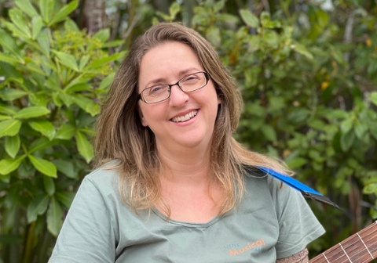
This year saw Emily continue in her role as Co-Editor of the New Zealand Journal of Music Therapy (NZJMT). Collaborating across time zones with her Co-Editor in the UK, Emily was really proud to oversee the publication of the 22nd edition of the journal in February this year. It was particularly special for the Little Musical Caravan that this edition included an article written by our very own TJ Hernandez, based on his Master of Music Therapy research about navigating oppression, power and privilege in music therapy spaces from his personal experience as a second-generation, New Zealand-born Filipino music therapist; TJ’s Article. Work progresses on this year’s issue of the NZJMT, with publication due early in 2026.
For health reasons, Emily has had to step back from her client facing work this year whilst she navigates ME/ CFS. However, Emily continues to work hard behind the scenes to ensure the smooth-running of the Little Musical Caravan and our base, Mana Therapy Hub. This year, she supervised Max, our music therapy student, acted as an External Examiner for one of NZSM’s Master of Music Therapy students and joined the Advisory Panel for NZSM’s Music Therapy programme. Emily is a constant innovator and loves learning, using the time away from client facing work to explore PD opportunities, including a certification in Play Therapy and a number of webinars about neuro-affirming practice. She also joined the Therapist Neurodiversity Collective and continues advocacy and advisory roles as spoons allow.

Telehealth Music Therapy
From term 1 2026, the Little Musical Caravan will be trialling telehealth sessions. We think this will be beneficial for our whānau who aren’t able to access our services at school or at Mana Therapy Hub. We will also be offering online sessions for tamariki that are not well enough for us to see in person, but who are well enough to engage in music therapy from home.
Funding update
Individualised Funding (IF), which is used by many of our whānau to access our music therapy services, came under threat last year but continued during 2025 which was a great relief for many of our whānau. In addition, carer respite funding can be used for funding music therapy; Disability support services guidance. We are aware that many family budgets became strained as cost of living challenges rose during the year and we continue to explore funding sources for our community-based work. If you know of anyone who could support our work, we’d love to hear from them!

Summer break and 2026 Re-start
The Little Musical Caravan will take a summer break from Friday 19 December through until Tuesday 20 January. The office will be closed during this time.
We will be offering some summer sessions for existing tamariki – bookings on My Music Staff open on Friday 12 December – as well as trial sessions for new whanau. Āhuru Mōwai Trust ‘taster’ sessions will take place on Thursday 29 January.
For music therapy at the LMC Hub, term starts on 2 February 2026. For tamariki accessing music therapy at school, the caravan will kick back into action from 9 February 2026.
Fees and travel charges for 2026
Our base fee for individual 30 min music therapy sessions has remained the same for 3 years at $85 + GST. Whilst we are very mindful of the impact the current economic climate has on our whānau, our running costs continue to increase. Because we want to keep offering music therapy, we need to consider our sustainability as a service. Therefore, in line with inflation, our fees for 2026 will be $110 for individual sessions. This is made up of a payment of $95.65 for the LMC plus an additional GST charge (which we are required to pay to the government).
Our charge for group sessions, adaptive piano lessons and other services will also increase slightly and we will be in touch with relevant parties in the New Year with further details.
Current relevant IRD rates for mileage, which now take account of the variable running costs of different vehicles are:
$1.17 per km for petrol vehicles
$1.08 per km for electric vehicles
The Little Musical Caravan team mostly uses a petrol car, but sometimes we are able to use an electric vehicle (EV) to drive to a site and this will be reflected in our travel charges. IRD typically announces the rate changes in June and if we travel to provide your tamariki with services, we will be in touch as soon as we are aware of the new mileage rates.
Reminders
- We have a dedicated parking spot for our Hub clients. Please use the number 1 parking spot, nearest the road. There is also parking available along the road (outside of clearway hours) and nearby at the train station.
- Invoices for ongoing therapy are sent at the end of each month for work done during the month with payment due within 14 days (unless you have a payment plan prearranged). We will be introducing a late fee for payments overdue by 21 days. Your prompt payment is appreciated so we can spend more time doing the music therapy and advocacy work we love instead of chasing missing payments!
- Should you find yourself in financial difficulties, please get in touch asap so that we can work out a way to support you and your tamariki.
- Please give us as much notice as possible if you need to cancel a session. We have a 24 hour cancellation policy.
- We work with a number of immunocompromised and vulnerable clients. For their health and our own, we ask that if your child is sick and is actively infectious (i.e. coughing, sneezing/ runny nose/ diarrhoea) you keep them at home. 48 hours’ clearance period is required for tummy bugs.
Season’s Greetings
Thank you for your collaboration with the Little Musical Caravan in 2025. As a team, we love connecting with, supporting and inspiring young people through musical relationships. We really value the support of the other people in their lives which make it possible for us to do what we do - parents, teachers, siblings, friends, funders, other support providers. We’re really looking forward to continuing our work with you all next year. We trust that you are able to enjoy some refreshing time together with the people you love over the summer. We are also mindful of families for whom this can be an extra-challenging time. However it is for you, we hope you’re able to find ways to play together and add some musical elements to your summer - whether it’s an upbeat road trip playlist, singing Christmas songs with others, transforming your gift packaging into home-made instruments or even perhaps heading to a show or free outdoor concert together. We look forward to hearing what you got up to in the New Year!

Ngā mihi maioha,

The LMC Team (Emily, TJ, Deb, Max and Liz).
www.littlemusicalcaravan.co.nz

